MECHANICAL HARDENING VAT VRM-S

TECHNICAL FEATURES

- Structure in stainless steel AISI 304 (UNI X 5 Cr Ni 18 10) with metal sheets 2,5 mm of thickness
- Made up of modular lengths measuring 4 m each
- Pipes in stainless steel AISI 304 for re-circulation and re-integration of the cooling water with internal and external welding in atmosphere of protective gas and external polishing
- Product advancement system with oscillating beds with perforated bases in stainless steel AISI 304
- Electrical motor for driving of the oscillating beds with two speeds (700 and 1.400 rpm)
- Product extraction belt with rods in stainless steel AISI 316 (UNI X 5 Cr Ni Mo 17 12) or in alternative, in modular plastic elements
- Centrifugal motor-driven pump in stainless steel AISI 304 for re-circulation and recovery of cleaning solutions
- Strainer for recovery of cooling water impurities
- Arrangement for connection to your plate heat exchanger for re-circulation of cooling water
- Electrical plant on machine border
- Waterproof control and power board in stainless steel assembled on machine border

DESCRIPTION AND WORKING

The hardening vat model VRM is realized by connecting some moduli of pre-defined length in stainless steel through bolts: the initial module bearing the motorization for advancement system, the final module containing the product extraction belt and, according to the length of the vat, one or more intermediate modules; during the working the continuous visual check of the cheese in the vat is allowed.
The product to be hardened, coming from the moulding machines is introduce through a loading hopper inside the vat; a series of oscillating beds in stainless steel put in action by a connecting rod mechanism and by a crank moves the product together with a series of water jets coming out from the holed pipes assembled inside the vat.
The electrical motor which puts into action the oscillating beds has two speeds (700 and 1.400 rpm) so that it is possible to choose two working cycles from the control panel: the normal production cycle is made up of slow advancement, fast return and stop for some seconds (chosen from the timer) so that the product advances along the vat; the standing cycle is made up of slow advancement and continuous slow return without stops, so that the product stays in the acquired position. When the hardening is ended the product is automatically conveyed out by a belt in stainless steel or in alternative, in modular plastic elements put in action by a geared motor unit.
A centrifugal pump has the double task of recycling the cooling water to the plate exchanger and recovering the cleaning solutions at the end of the working.
Electrical controls are housed in a waterproof board in stainless steel, inside which there is also the power part.

TECHNICAL DATA

MODEL | VRM5-1,5S | VRM7-1,5S | VRM9-1,5S | VRM13-1,5S
DIMENSIONS | 5,2x1,7x0,8 m | 7,2x1,7x0,8 m | 9,2x1,7x0,8 m | 13,2x1,7x0,8 m
CAPACITY | 2.600 l | 3.600 l | 4.700 l | 6.800 l
MASS | 1.100 kg | 1.500 kg | 2.000 kg | 2.900 kg
CIP CAPACITY | 30.000 l/h | 38.000 l/h | 46.000 l/h | 60.000 l/h
RATED POWER | 6,5 kW | 6,5 kW | 6,5 kW | 6,5 kW
VOLTAGE | 400 V - 3ph | 400 V - 3ph | 400 V - 3ph | 400 V - 3ph
FREQUENCY | 50 Hz | 50 Hz | 50 Hz | 50 Hz

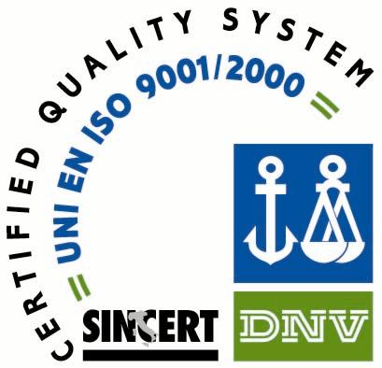

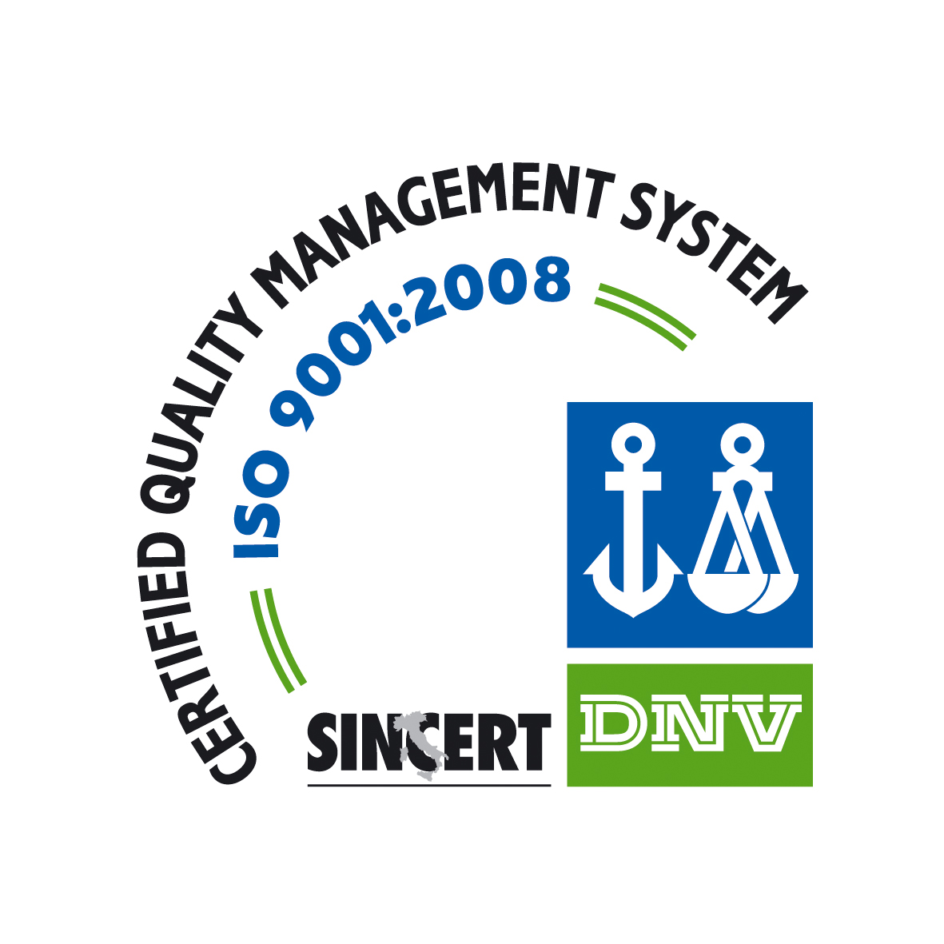

COSTRUZIONI MECCANICHE E TECNOLOGIA SpA
Via Cuneo, 130 - 12016 Peveragno (Cn) - Italia
Tel. +39 0171 339456 - Fax +39 0171 339771 - email: info@cmt-spa.com

